Neuron

# Preceptron

A Perceptron takes several binary inputs,x1,x2,…., and produces a single binary output . So you can see that we have got 3 inputs x1,x2 and all of these have got random weight “w0,w1,w2” and the output will be the sum of “x*w1+w2+b” and we add bias in this. This is how a perceptron works.

The goal of the perceptron is to correctly classify the set of externally applied stimuli (x1, x2,..., xm) into one of two classes,c1 or c2. The decision rule for the classification is to assign the point represented by the inputs x1, x2,..., xm to class c1 if the perceptron output y is +1 and to class c2 if it is -1

Types of transfer function

Threshold function - perceptron

Sigmoid:

* For big potential values the value of sigmoid function – 1. For smaill – 0

Parameter lambda – how quickly sigmoid function changes around zero. Lambda > 1 – changes quickly.

Function is continuous and smooth.

Radial basic (RBF) - gaussian (?)

Wavelet - far away from separating plan now activity can be seen.

**Neuron (Def) – formal definition**

Neuron states:

Training

Supervised – training set of the form [ input / desired output]

Self-organization – no desired output ⇒ Goal: setting (adaptation) of the synaptic weights

Recall: of newly presented input patterns => Goal: get the response (output) of the neural network

**Training patterns (Def)**

**Perceptron (Def)**

**Linear Separability (def)**

Two sets of points 𝑨 and B are called linearly separable in an 𝒏-dimensional space, if 𝒏 + 𝟏 real numbers 𝒘𝟏, … , 𝒘𝒏, , 𝝑 exist, such that every point 𝑥1, 𝑥2, … , 𝑥𝑛 ∈ 𝐴 satisfies A black text on a white background

**Absolute linear separability: (Def)**

Two sets A and B are called absolutely linearly separable in an 𝒏-dimensional space, if 𝒏 + 𝟏 real numbers w1 , …, wn , ϑ exist, such that every point 𝑥1, 𝑥2, … , 𝑥𝑛 ∈ 𝐴 satisfies A black text on a white background

Theorem: (proof on slides)

Two finite sets of points A and B , that are linearly separable in an n-dimensional space, are also absolutely linearly separable

Separating hyperplane – for the extended weight and feature space

Problem: Find such weights and threshold capable of absolutely separating two sets => e.g., PERCEPTRON LEARNING ALGORITHM

SEPARATION of A and B:

The goal of learning: minimize E(w) in the weight space (E(w) = 0 )

**Perceptron learning algorithm**

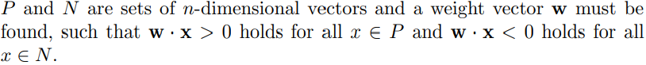

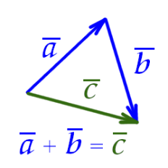

Convergence

If the sets P and N are finite and linearly separable, the perceptron learning algorithm updates the weight vector a finite number of times.

**The pocket algorithm**

If the learning set is not linearly separable the perceptron learning algorithm does not terminate

The main idea of the algorithm is to store the best weight vector found so far by perceptron learning (in a “pocket”) while continuing to update the weight vector itself. If a better weight vector is found, it supersedes the one currently stored and the algorithm continues to run

The algorithm can occasionally change a good stored weight vector for an inferior one, since only information from the last run of selected examples is considered. The probability of this happening, however, becomes smaller and smaller as the number of iterations grows. If the training set is finite and the weights and vectors are rational, it can be shown that this algorithm converges to an optimal solution with probability 1

